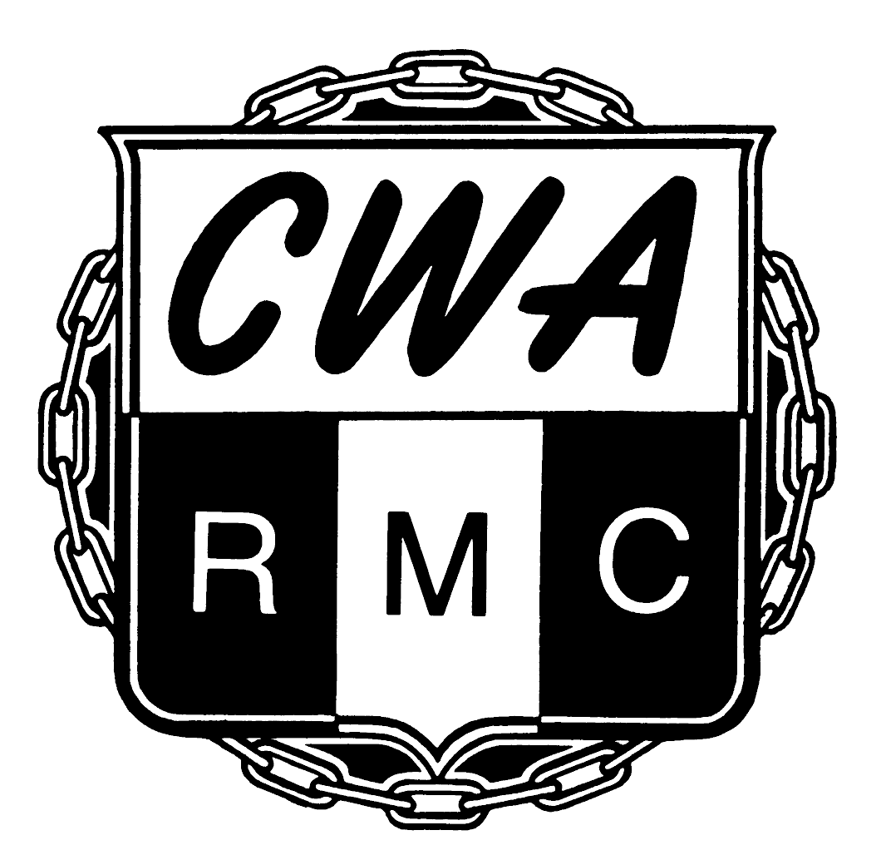
CWA Retired Members' Council
501 3rd Street NW
Washington DC 20001-2797

Order Form

(kindly print)

Name _________________________________________________________
Local/Chapter ________________
Address _______________________________________________________
City/State/Zip __________________________________________________
Telephone _____________________________________________________
Email _________________________________________________________
Please send
____ CWA RMC purple ball point pens (blue ink) at $2 each or 3 for $5

____ Red RMC tee shirts (sizes noted below) I understand that for every 10 shirts I order, I get one free.

____Purple RMC tee shirts (sized noted below)

Size | Unit Price | Quantity | Total Price
Small | $15
Medium | $15
Large | $15
Extra Large | $15
2X | $18
3X | $18
4X | $18
 | SHIRT TOTAL

Enclosed is our check/money order for $_________________

(for internal use only)
Shirts shipped on _____________ by (circle one) UPS USPS

