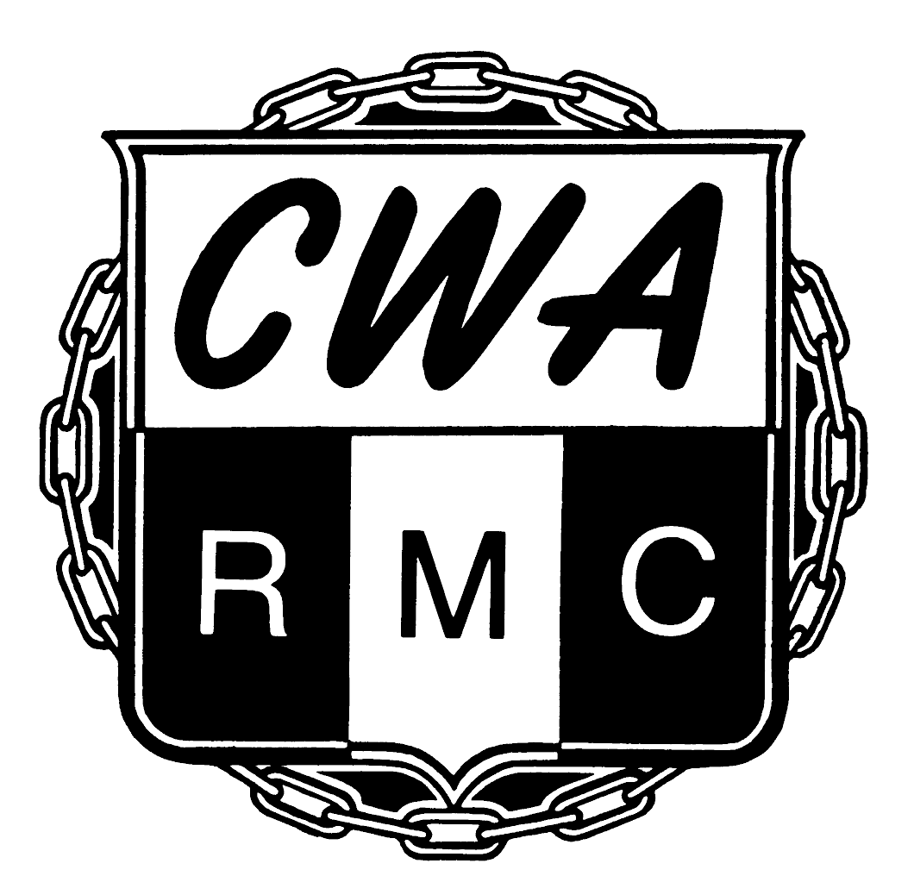
CWA Retired Members' Council
501 3rd Street NW
Washington DC 20001-2797

Order Form
Pocket Calendars, Lapel Pins, Tote Bags, Pens

(Kindly print)

Name _________________________________________________________
Local/Chapter ________________
Address _______________________________________________________
City/State/Zip __________________________________________________
Telephone _____________________________________________________
Email _________________________________________________________

Please send:

____ 2010 RMC weekly pocket calendars @ $2.00 each or 3 for $5

____ RMC tote bags @ $3.00 each

____ RMC logo lapel pin @3.00 each

____ RMC ball point pens @ $2.00 each or 3 pens for $5.00

____ Big Yellow 3” CWA Retired Member pin Free

____ Enclosed is our check/money order for $_________________

Date: __________

(For internal use only)
Items shipped on _____________ by UPS or USPS

