CWA Retired Members’ Council
Lifetime Membership
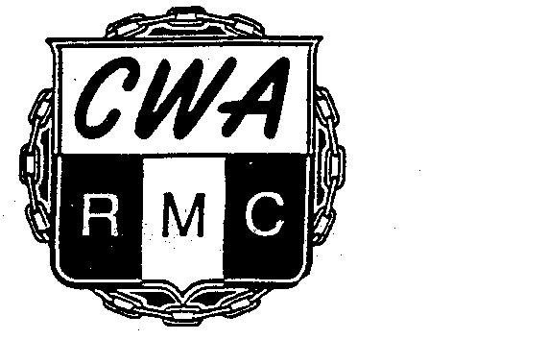

We encourage you to join, by working together we can help increase CWA’s bargaining power with employers as we fight to protect our retirement.

Yes, sign me up for Lifetime membership in the CWA Retired Members’ Council!
Here’s my one-time $25 payment to the Council for Lifetime membership.

(Kindly print)
Name __________________________________________________

Address ________________________________________________

City/State/Zip ____________________________________________

Home Phone __________________ Cell Phone ________________

Email __________________________________________________

Home Local _____________ Former Employer _________________

Payment Method for Council Lifetime Membership Fee:

___ Here is my $25 check made payable to the CWA Retired Members’ Council

___ Charge the $25 fee to my credit card: ___Visa ___MasterCard ___Discover

Card Number:

Expiration Date:
/

_______________________________________ ______________
Signature Date

Please mail to CWA Retired Members’ Council, 501 3rd St NW, Washington, DC 20001-2797

Thank you

