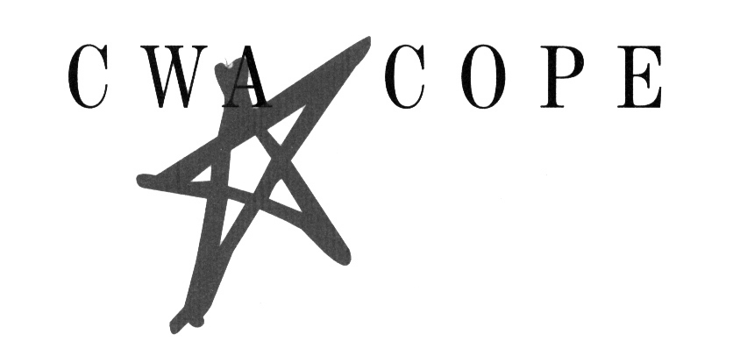 | CWA Retired Members’ Council  COPE CHECK-OFF  (Direct Debit of Monthly Donation)

I hereby authorize the Communications Workers of America Committee on Political Education Political Contributions Committee, hereinafter called the CWA-COPE PCC to initiate a monthly debit to my

Checking Account Savings Account

in the amount of (circle one): $4 $6 $8 $10 per month.

**I understand I am entitled to a COPE incentive award based on my monthly contribution. I have indicated my choice on the reverse of this document**

Attach a Void Check Here – Very Important

NAME OF BANK _________________________________________________

CITY AND STATE ________________________________________________

This authorization is to remain in full force and effect until the CWA-COPE PCC and the bank have received written notification from me of its termination in such time and in such manner as to afford the parties a reasonable opportunity to act on it.

Signature and Date ____________________________________________________

Print Name __________________________________________________________

Email ______________________________________________________________

Mailing Address______________________________________________________________

_________________ Retired _____________________________________
Chapter Number (if known) Occupation Social Security Number (for verification purposes only)

This Authorization is voluntarily made based on my specific understanding that:
- The signing of this authorization card and the making of contributions to CWA-COPE PCC are not conditions of membership in the Council and that I may refuse to do so without fear of reprisal.
- I am making a contribution to a joint fund-raising effort sponsored by CWA-COPE PCC and the AFL-CIO Committee on Political Education Political Contributions Committee (AFL-CIO COPE PCC) and that CWA-COPE PCC and AFL-CIO COPE PCC will use my contributions for political purposes, including but not limited to, the making of contributions to or expenditures on behalf of candidates for federal, state and local offices and addressing political issues of public importance.
- Contributions to CWA-COPE PCC and AFL-CIO COPE PCC are not deductible as charitable contributions for federal income tax purposes.
- In the event a debit is made to my account in error, I authorize CWA-COPE PCC to make the correction under the condition that I am notified of the adjustment.

___________________________________________________________________
(Signature of Union Representative Certifying that Retiree is Eligible to Participate)

Please be sure to attached your void check and to choose your Incentive Award (see other side)

Send to | HELEN GIBSON  CWA RETIRED MEMBERS COUNCIL  501 3RD STREET, NW  WASHINGTON, DC 20001-2797

RMC COPE
INCENTIVE AWARD PROGRAM

Please indicate your level of giving and your choice of award incentive:

_____ COPE Club - $4 per month
____ New Era Cap or
____ Tumbler

_____ Platinum Quorum - $6 per month
____ Note Jotter or
____ Weekender Wallet

_____ Triple Quorum - $8 per month
____ Duffle Bag or
____ 26 Quart Cooler

_____ President’s Club - $10 per month
____ CWA Watch or
____ Day Calendar or
____ 5” Knife

